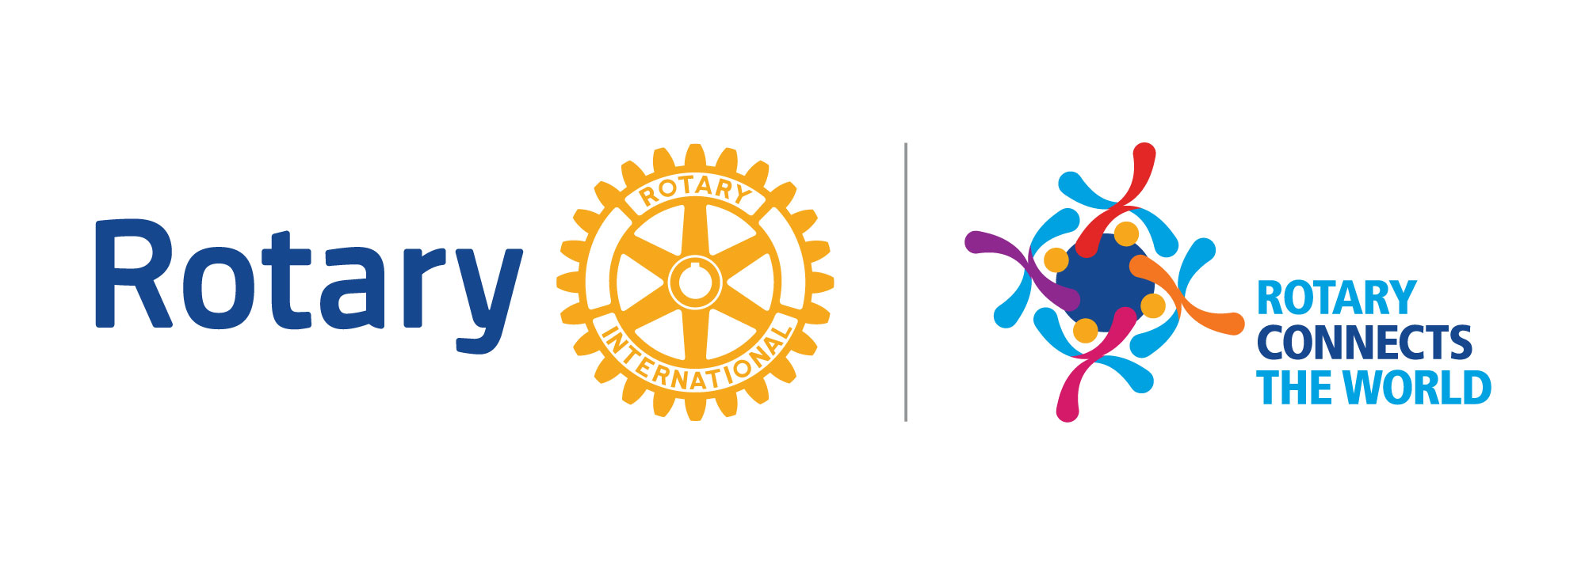

ROTARY GRANTS: 2020-21 ROTARY YEAR - DISTRICT 6780

CLUB QUALIFICATION MEMORANDUM OF UNDERSTANDING - THE ROTARY FOUNDATION

1. Club Qualification
The Rotary Foundation (TRF) requires that clubs who wish to participate in District or Global Grants must agree to the terms for financial and stewardship requirements in this Memorandum of Understanding (MOU), and to send at least one club member each year to the district’s Grant Management Seminar.

The Rotary Foundation enables a district to establish additional requirements for club qualification for those grants, as well as for District Grants.

Rotary District 6780 requires that a minimum of two club members must attend a Grants Management Seminar each year, and that one of those two members must be the President-Elect. The other member(s) should be the club member(s) that would normally complete and be responsible for the District and or Global Grant applications.

Rotary International (RI) STRONGLY recommends all clubs input their club goals (all of them) into Club Central. TRF is most concerned with the Foundation goals. As RI and TRF seek partners such as the Gates Foundation, Coca Cola, and other NGO's they ask what Rotary's monetary commitment will be. If the goals are not entered, the result is RI and TRF cannot give an approximation.

As part of District 6780's compliance with TRF, all clubs seeking District & Global grants must input their goals prior to submitting their grant application. Grants and grant funds will only be released to clubs having completed this task.

Included in the signature page of the MOU clubs will be required to answer the following questions:
- What was your Foundation giving last year (actual) 2018-19?
- What is your Foundation goal for 2019-20?
- Have your club goals (all of them) been inputted into RI Club Central?
- What is your club mailing address? (we need this to mail you your grant funds)

Upon successful completion of the qualification requirements, the club will be qualified for one Rotary year.

The club must comply with this MOU, any district requirements, and all applicable TRF policies and cooperate with any financial, grant, or operational audits.

The club is responsible for the use of funds for club-sponsored grants, regardless of who controls the funds.

Qualification may be suspended or revoked for misuse or mismanagement of grant funds involving, but not limited to: fraud; forgery; membership falsification; gross negligence; endangerment of health, welfare, or safety of beneficiaries; ineligible contributions; use of funds for personal gain; undisclosed conflicts of interest; monopolization of grant funds by individuals; report falsification; overpricing; acceptance of payments from beneficiaries; illegal activities; and/or use of grant funds for ineligible purposes.

2. Club Officer Responsibilities
The club officers hold primary responsibility for club qualification and the proper implementation of grants. The club officers are responsible to ensure the following:

- Appoint at least one club member to implement, manage, and maintain the club qualification;
- Ensure that all TRF Grants adhere to stewardship measures and proper grant management practices;
- Ensure that all individuals involved in a grant conduct their activities in a way that avoids any actual or perceived conflict of interest.

3. Financial Management Plan
The club must have a written financial management plan to provide consistent administration of grant funds, and the financial management plan must include procedures to:

- Maintain a standard set of accounts, which includes a complete record of all receipts and disbursements of grant funds;
- Disburse grant funds, as appropriate;
- Maintain segregation of duties for handling funds;
- Establish an inventory system for equipment and other assets purchased with grant funds, and maintain records for items that are purchased, produced, or distributed through grant activities;
- Ensure that all grant activities, including the conversion of funds, comply with local law.

4. Bank Account Requirements
To receive grant funds, the club must have a dedicated bank account that is used solely for receiving and disbursing TRF grant funds.

The club’s dedicated account must:

- Have a minimum of two Rotarian signatories from the club for disbursements from the grant account; and
- Be a low or non-interest-bearing account. Any interest earned must be documented and used for eligible, approved grant activities, or returned to TRF.

The club must:

- Open a separate account for each club-sponsored grant, with the name of the account to clearly identify its use for grant funds. Grant funds may not be deposited in investment accounts including, but not limited to, mutual funds, certificates of deposit, bonds, and stocks.
- Retain bank statements and records to support the receipt and use of TRF grant funds.
- Maintain a written plan for transferring custody of the bank accounts in the event of a change in signatories.

5. Report on Use of Grant Funds
The club must adhere to all TRF reporting requirements. Grant reporting is a key aspect of grant management and stewardship, as it informs TRF of the grant’s progress and how funds are spent.

6. Document Retention
The club must establish and maintain appropriate record keeping systems to preserve important documents related to qualification and TRF grants. Retaining these documents supports transparency in grant management and assists in the preparation for audits or financial assessments.

Documents that must be maintained include, but are not limited to:

- Bank information, including copies of past statements;
- Club qualification documents including a copy of the signed club MOU;
- Documented plans and procedures, including:
- Financial management plan,
- Procedure for storing documents and archives,
- Succession plan for bank account signatories and retention of information and documentation;
- Information related to grants, including receipts and invoices for all purchases.

Club records must be accessible and available to Rotarians in the club and at the request of the district.

Documents must be maintained for a minimum of five years, or longer if required by local law.

7. Reporting Misuse of Grant Funds
The club must report any potential and real misuse or mismanagement of grant funds to the district. This reporting fosters an environment in the club that does not tolerate the misuse of grant funds.

District 6780 Memorandum of Understanding (MOU) – Signature Page

This Memorandum of Understanding is an agreement between the club and the district and acknowledges that the club will undertake measures to ensure the proper implementation of grant activities and proper management of grant funds from The Rotary Foundation. By authorizing this document, the club agrees to comply with all the conditions and requirements of the MOU.

On behalf of the Rotary Club of ________________________________________________, the undersigned agree to comply with all the conditions and requirements of the MOU for Rotary year 2020-21 and will promptly notify RI District 6780 of any changes or revisions to club policies and procedures related to these requirements. President-
Mailing address of Club: _______________________________________________________

_______________________________________________________

_______________________________________________________

- What was your Foundation giving 2017-18? _____________________

- What is your anticipated Foundation giving for 2020-21? _____________________________________

- Have your club goals (all of them) been inputted into RI Club Central? ______________

President 2019-2020 President-Elect 2020-21

Name: ____________________________ Name: _____________________________
Please print Please print

Signature ________________________ Signature _______________________

Date: _______________________ Date: ________________________
Email address: ______________________ Email address: _____________________
Phone: _____________________________ Phone: ____________________________
Cell: _______________________________ Cell: _______________________________

Date of Grant Management Seminar attended: ____________________________

Verified by: __________________________
District 6780

Please check if additional members have been added to the back of this page.



DISTRICT 6780 - CLUB QUALIFICATION PLAN

The Rotary Foundation’s Club Memorandum of Understanding (MOU) lists what your club needs to do to comply with Grant requirements. This Club Qualification Plan lays out how you are going to do it. The MOU is an agreement between the club and its district, and must be resigned every year to ensure proper implementation of global and district grant activities and management of Rotary Foundation Grant funds. This supporting plan must be reviewed and revised at that time, and can also be revised any time during the year by sending an update to the District 6780 Club Qualification Officer.

Please complete this form and return it with your club’s MOU. This is an MSWord writeable document which may be completed on your computer (fields expand as needed) or printed and completed by hand. If completed by hand, attach extra pages if required.

Rotary Club of Date

Club Leadership Responsibilities for Qualification
- A club member must be appointed to manage club qualification and ensure that stewardship measures and proper grant management practices are implemented for all TRF grants.

Please enter the name of this Rotarian:
NAME:
E-MAIL
Preferred Telephone Number

- Disclose potential conflicts of interest and describe how your club will handle stewardship of funds and manage potential conflicts of interest: (Field will expand as you type.)

- Every year the club president-elect or a club-designated appointee must attend grant management and qualification training arranged by the district.

Did club president-elect or a club-designated appointee attend seminar? Yes No

List below all the active club members who have attended Grant training in the last 5 years:

Name | Date trained

Financial Management
- The club must maintain a bank account for Global Grants to be used only for Rotary Foundation Grant funds in accordance with applicable laws. Please choose one of three options:
No Global Grants anticipated.
The District 6780 Grants account will be used for our Global Grant(s).
Our Club’s Grants account is listed below.

NAME OF BANK:
NAME OF ACCOUNT:
1ST SIGNATORY NAME: (Print)
2ND SIGNATORY NAME: (Print)

- The club must have a financial management plan that complies with the Financial Management section of the MOU. Please explain your plan:

Please provide the following information:

HAVE ACCOUNTS AND RECORDS BEEN ESTABLISHED? |  |  |  | YES No
DOES YOUR FINANCE PLAN COMPLY WITH THE MOU? |  |  |  | YES No
WHO IS THE PRIMARY PERSON RESPONSIBLE FOR MAINTAINING THESE ACCOUNTS AND RECORDS?
TELEPHONE NUMBER:
E-MAIL ADDRESS:

4. Document Retention
- The club must have a document maintenance system or club archives to maintain original documents as required in the MOU. Please describe how you do or will do this:

Please provide the following information:
HAS RECORD RETENTION SYSTEM BEEN ESTABLISHED? |  |  |  |  | YES No
WHERE ARE THESE RECORDS KEPT?
WHO IS THE PRIMARY PERSON RESPONSIBLE FOR MAINTAINING THIS SYSTEM?
TELEPHONE NUMBER:
E-MAIL ADDRESS:

5. Report on Use of Grant Funds
Who will submit the reports for your District and/or Global Grants?

6. Method for Reporting Misuse of Grant Funds
The Club must report any potential misuse or irregularities in grant-related activity to the District. How will you do this?

7. Authorization and Agreement
We, being responsible for administering grant activities for the Rotary Club indicated below, certify that the club adheres to the requirements listed in the Memorandum of Understanding and that the statements made above are accurate.

The Rotary Club of

Club President |  |  | Club President-Elect
Term |  |  | Term
Name |  |  | Name
Signature or e-mail address* |  |  | Signature or e-mail address*
Date |  |  | Date
*Signatures are not required if submitted via e-mail with both parties listed in the address line.

